Preparing for the Falsified Medicines Directive – FMD (2019)

Enforcement date: 9th Feb 2019 - at which time all pharmacies must have implemented procedures
Following adoption by the European Council and the European Parliament, the Falsified Medicines Directive (Directive 2011/62/EU) was published on 1 July 2011, and applies since 2 January 2013. It amended Directive 2001/83/EC. This Directive introduces harmonised European measures to fight medicine falsifications and ensure that medicines are safe and that the trade in medicines is rigorously controlled. Measures include:
- Obligatory safety features – a unique identifier and an anti-tampering device - on the outer packaging of medicines
- A common, EU-wide logo to identify legal online pharmacies
- Tougher rules on import of active pharmaceutical ingredients
- Strengthened record-keeping requirements for wholesale distributors.
Overview

The Directive on the Falsified Medicines was legislation passed by the European Union Parliament, which aimed to increase the security of the manufacturing and delivery of medicines in Europe and provide protection to patients from falsified medicines in the legal supply chain of pharmaceuticals.
From 9th February 2019, market authorisation holders are required to place two safety features on all new packs of prescription medicines placed on the market in Europe:
- a unique identifier (UI) in the form of a 2D data matrix (barcode) which can be scanned at various points along the supply chain to determine its authenticity; and
- an anti-tamper device (ATD).
In order to comply with the requirements of FMD, pharmacy contractors will be required as part of the dispensing process (from 9th February 2019 and for products that bear safety features) to:
- check the anti-tampering device (ATD) to ensure it is intact prior to dispensing; and
- change the status of the pack in the UK’s National Medicines Verification System from “active” to “inactive—supplied”. This involves scanning the 2D barcode on each pack and communicating with the National Medicine Verification System (NMVS).
The Delegated Regulations [Article 25(1)] state that these steps should occur “at the time of supplying it to the public”
Verification & Decommissioning

When to Decommission?
Pharmacies will be required to authenticate products, which means visually checking the anti-tamper device and performing a verification and decommissioning scan, “at the time of supplying it to the public”. Although the term “time of supply” is ambiguous within community pharmacy, what is clear is that the FMD process must have been completed at the point the medicine is released to the patient or their representative. One way of doing this efficiently, where more than one product is involved, is to use an aggregated barcode on the bag label.

Aggregated Barcodes
Aggregated barcodes are not required under the Delegated Regulation but may be generated by pharmacy IT systems to link several pack identifiers together, if this functionality has been provided by the IT supplier. They are not mandatory, but may be used to facilitate decommissioning. Aggregated codes may be printed directly on dispensing bags, or on a separate adhesive label to be applied to dispensing bags, and then scanned at the time of supply. Aggregated barcodes could either contain all of the data of the pack identifiers or simply provide a link to the data stored on the pharmacy IT system.

What’s In and Out of Scope?
Almost all prescription medicines with a Marketing Authorisation are in scope of FMD with only a few specialist products, radionuclide kits and medicinal gases being out-of-scope. All non-prescription medicines are out-of-scope, with the exception of two omeprazole products (which were subject to falsification in the past).
Unlicensed products, including specials and clinical trial supplies, are out-of-scope, but any licensed products being incorporated into them (such as ingredients for specials) would have to be authenticated and decommissioned before they could be used.
Medical devices are out-of-scope, but separate changes are being made to regulation of medical devices.

Verification and Decommission Options

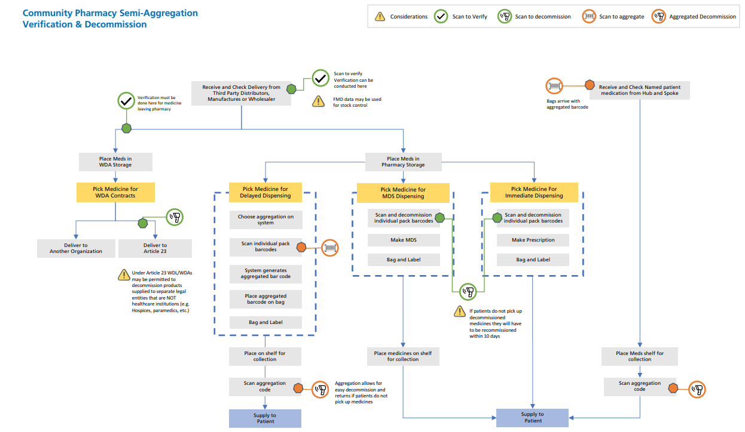

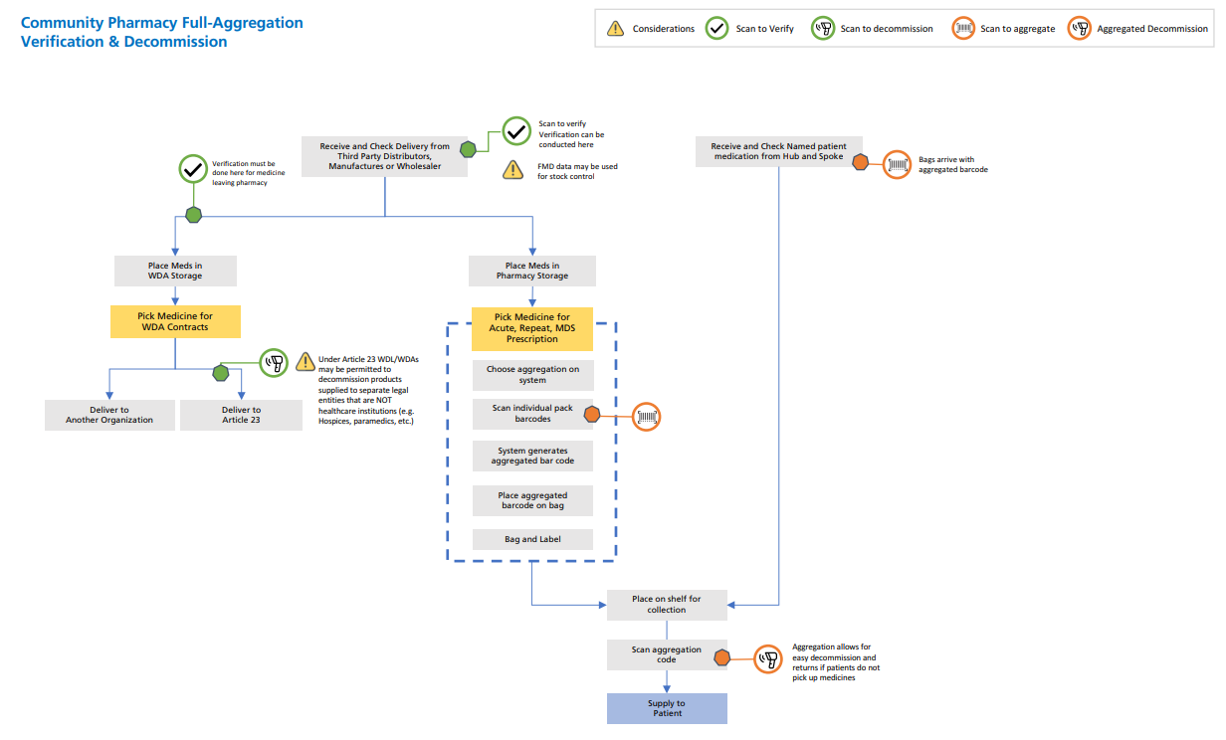
Implementation and transition
The EU Delegated Regulation only applies to new stocks of products released to the market on or after 9th February 2019. Older packs do not have to be withdrawn and can still be supplied to patients after this date. Manufacturers are beginning to change production to incorporate the new 2D data matrix barcodes on their packs but it is expected that there will still be a considerable volume of older products in stock and in the supply chain and a long transition period is expected.
Levels of FMD-compliant stock will increase over time and the amount of verification, authentication and decommissioning to be carried out in pharmacies will increase in proportion until all stock is fully compliant. FMD does not apply to OTC products, medical devices and some specialist products.
At the time FMD comes in to force, there may be existing products in the system that bear 2D data matrix barcodes but which have not had their unique identifier data uploaded in to the verification system, or where data uploads take place retrospectively. Pharmacy teams will need to take great care in dispensing these products.
It is expected that during the transition period all new stock will bear 2D data matrix barcodes and so the older linear barcodes will gradually disappear from prescription medicines.
IT System Requirements

Registration of Community Pharmacies
Each community pharmacy in the UK will need to connect to the NMVS being set up by SecurMed UK so that FMD verification scanning and decommissioning can occur. The process of identifying legitimate pharmacies and granting them an account to connect is known as “registration” (or sometimes as “on-boarding”) and will need to be completed well before 9th February 2019.

Stand Alone System
Best Suited for: Small Volume Decommission
These systems work independently from other software solutions and support communication with the National Medicines verification Service (NMVS) on barcode scanning facilitated by a member of staff.
Selection of any system should include a check that the system can deal appropriately with the volume of items to be scanned and the ‘cost’ of the system should include the staff time taken in scanning items for verification and decommission.
Delegated staff member scans medicines using a 2D compliant scanning device. Staff then have to manually enter relevant data into any existing system to record dispensing activity and deduct from stock.
- Total Manual Process
- Increased labour time
- Lowest Cost Option

IT Systems – Expected Standard Requirements
The following requirements reflect the expectations of the UK FMD Working Group for Community Pharmacy of what suitable FMD-compliant systems should be capable of delivering. Reference should also be made to the User Requirement Specification produced by the EMVO and any guidance produced by SecurMed UK and/or Arvato Systems. Minimum requirements to meet obligations under the Delegated Regulation are indicated thus [Minimum]:
• The scanners used must be able to scan:
o Barcodes on prescriptions or tokens (including on a smartphone screen)
o FMD unique identifier 2D data matrix codes [Minimum]
o Aggregated barcodes (if used)

Ideally, the system should be able to cope with wired and/or wireless scanners. It should also be able to scan existing linear barcodes on other pharmacy stock (and possibly QR or other information codes) Where possible, existing scanners (if able to scan 2D barcodes) should be reused. Changing scanners in automated systems or robots may be problematic.
• The system must allow [Minimum]:
o Verification scans
o Decommissioning scans
o Re-commissioning

• The system must allow feedback to the user [Minimum]:
o Current pack status for verification scans o Successful decommissioning
o Decommissioning “errors” (including “not detected on system” for those items which did not have their data uploaded before 9th Feb 2019)
o Decommissioning “failures” (i.e., pack identifier previously dispensed in same pharmacy, another location, another country)
o Other system errors, including temporary lack of connection to NMVS o Successful re-commissioning where appropriate

Where possible, visual and audible feedback (and associated messages) should be harmonised across different operating locations in the same country. Audible warning should be able to be turned off if required. See error messages flowchart as follows:

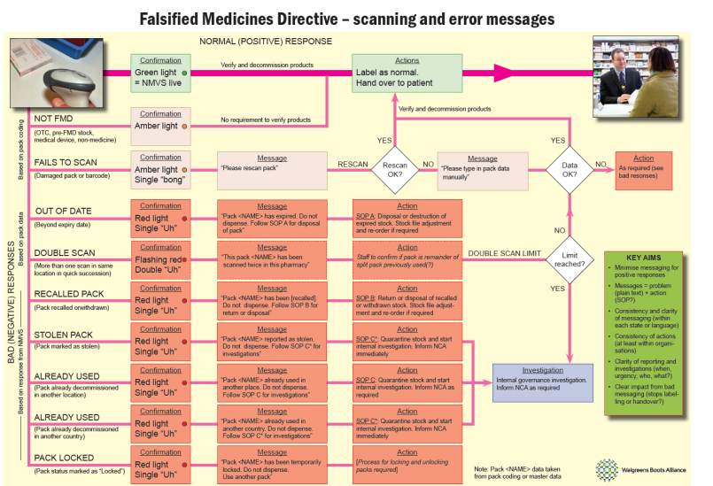
A success sound is to be added too. The sounds and error messages need piloting.
• FMD-capable systems need to have a suitable offline feature to ensure continuity of medicine supply to the public. No user action should be needed to go offline/online. FMD-capable systems will deal with outstanding FMD requests on reconnection to the NMVS. [Minimum]
• Alert the user on detection of falsified, expired or recalled medicines (either at the time of scanning, or as soon as the NMVS connection is restored). [Minimum]
• Manual (keyboard) entry of the unique identifier must be supported (for exceptional circumstances such as where the pack is damaged). [Minimum]
• In the UK we do not exclusively use whole pack dispensing. Packs of medicines can be legitimately split within the pharmacy to allow for dispensing a different number of tablets to the number within the pack, or to allow hydration/dilution, or to dispense a measured dose of a liquid for supervised consumption, or for MDS (monitored dosage system), or for pouching etc. The system must support pack splitting. If a prescription needs you to split a pack, check the tamper-evident seals, decommission, open the pack, then use it as required without any further requirement to scan.
• The software must allow reversal of decommissioning within the 10-day period permitted. [Minimum]
• The system should allow an option to not use aggregated codes and to decommission during assembly. The option must be available for each prescription, and as a system configuration setting for each terminal.
• The system should allow the connection of multiple scanners or terminals and be able to process multiple decommissioning requests and their results simultaneously. It must be clear which NMVS feedback message corresponds to which user/scan activity when multiple users are using the same terminal.
• The system should be able to print multiple aggregated bag labels for the same patient and link them together. This could be used, for example:
o Where prescription items include a fridge line or Controlled Drug
o Where prescription items are split across a number of bags due to their size
Where a bag is one of many for the same patient, the system should warn when there are more bags to retrieve and scan – where possible this should incorporate a configurable “chaos storage” solution which contractors can use if they wish.

• The system must also be able to carry out automated expiry date checking using information from the 2D code. This applies to all three scan types – verification, decommissioning and recommissioning
• The contractor will need to ensure that their broadband connection is appropriate in terms of speed, capacity and latency. This will need NHS involvement for the SWAN connections in Scotland (and possibly similar for the other home countries.)
• The system should provide limited management information, eg, simple number of scans conducted in a given period. This should be accessible from Head Offices where appropriate.

IT Systems – Optional Requirements
• FMD-capable PMR systems may store FMD requests/results against the patient record which may support recalls. At this stage this does not imply an automated accuracy check between prescription and patient, or patient level recalls, but they may be future developments.
• FMD-capable PMR systems may use FMD requests/results stored against the patient record to support recalls/decommissioning failure identified after reconnection to the NMVS.
• The pharmacy IT system may check that pack product data (eg, Global Trade Item Number, GTIN) matches equivalent information on prescriptions (potentially using dm+d codes) during verification or decommissioning scans (ie, automated accuracy checking)
• The system may co-operate with EPOS (electronic point of sale) modules or systems.
• The system may use product data from unique identifiers gathered from scans to aid stock control and re-ordering.
• Detailed management information – terminals/users who conducted the scan, proportion of items dispensed, scans conducted, etc.
• The ability for contractors to link verification scans on receipt of an order into the pharmacy to the wholesaler the product was received from to facilitate any returns due to negative or failed scans.

Response to negative or failed scans
If a scan gives an error, then the pharmacy may need to contact the National Competent Authority (in the UK this will be the MHRA) in some circumstances. For instance, a stolen or already-dispensed pack would need reporting, but an out-of-date one could not be used but would not need reporting.

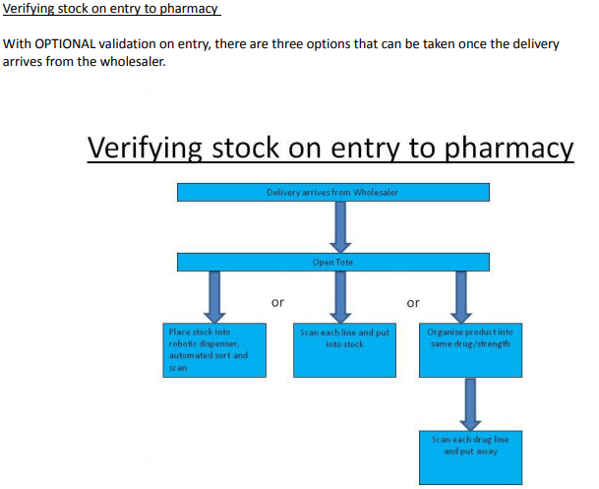

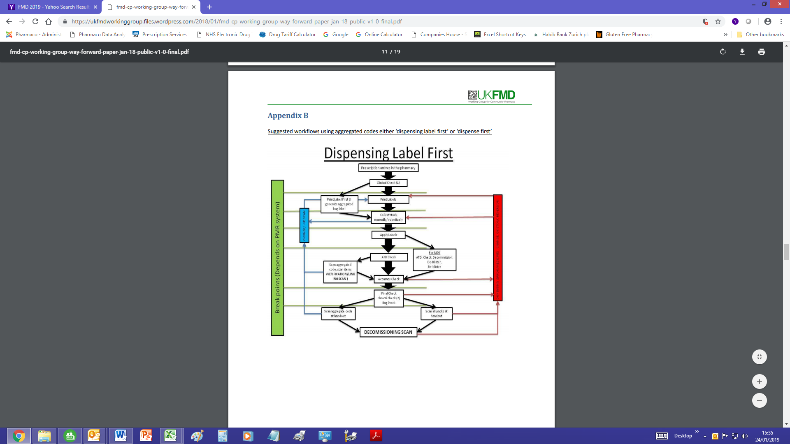
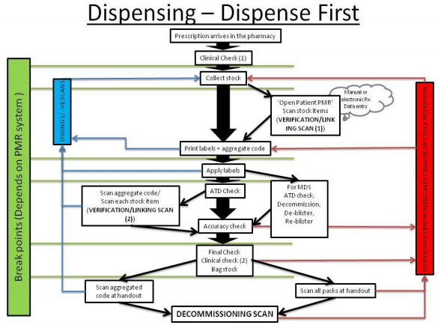
FMD Jargon Buster

FMD operations
Safety features: Under FMD, all new packs of prescription medicines placed on the market from 9th February 2019 onwards are required to bear safety features in order to reduce the risk of falsified products reaching patients. These features are the serialised unique identifiers and an anti-tampering device.
Unique identifiers: (UI): Each and every pack of prescription medicine will have to carry its own unique identifier, encoded in a machine-readable 2D data matrix (or barcode) that meets ISO standards. Unless the packaging is very small, part of this information will also appear in printed human-readable form. The unique identifier will contain the following information [Article 4]:
• Product code: the name, common name, pharmaceutical form, strength, pack size and pack type
• Serial number: randomised numeric or alphanumeric sequence of up to 20 characters
• National reimbursement number: national identifying code, if required by Member State
• Batch number: up to 20 characters
• Expiry date: in YYMMDD form

Anti-tampering device (ATD): Every pack has to have some sort of anti-tampering device which allows visual identification as to whether the pack may have been tampered with since it was originally manufactured (or repacked, for parallel traded products). Neither the Directive nor the Delegate Regulation specifies the nature of the ATDs that can be used, but typical devices could include glued-down flaps, seals or labels that have to be broken when opening, shrink or film wraps, breakable or tear-away closures, film or foil blister packs, and blow-fill-seal unit packs. Because of the variable type and locations for ATDs, inspection of them is always likely to be a human activity that would be difficult to automate.

Verify/verification: In order to verify a product in their possession, the person holding the medicine (normally a wholesaler or pharmacy) scans the unique identifier and then uses the NMVS to compare the data in the pack UI with corresponding data held in the NMVS. If the two match, and the anti-tampering device is still intact, then the pack is considered authentic. As long as it still has an active status, it can be moved through the supply chain or supplied to a patient (after decommissioning). Packs can be verified multiple times as they pass through the supply chain, as long has the person doing the verification has the product in their possession. Packs must be verified at certain points – if they have been bought from a secondary supplier rather than the original manufacturer or their agent; before they are repackaged for parallel trading; if they have been returned from a pharmacy back to a wholesaler.

Authentication: The processes of verification and authentication are closely linked and involve similar steps. In practice, authentication generally refers to the final step in the process, leading to decommissioning. Under Article 25, persons authorised to supply medicines to the public must authenticate the product by verifying the unique identifier using a NMVS and check that the antitampering device is still intact. This needs to be done “at the time of supplying it to the public”, although in practice it is likely that authentication will take place during the assembly and dispensing of prescribed medicines, rather than in front of the patient at the point of hand-over.

Decommissioning: Once the product has been authenticated during the dispensing process, it must have its status in the NMVS changed from active to inactive – decommissioned/supplied. This indicates that it has been dispensed and prevents any other pack bearing the same unique identifier from being dispensed, as the second attempt to verify the product would fail. This process of decommissioning underpins the operation of the repositories system and is aimed at preventing falsified products from reaching patients.

Active/inactive status: Each unique identifier that is uploaded to the repositories system has a status associated with it. Products with an active status can be dispensed or moved through the supply chain. Products with an inactive status cannot be supplied further, other than in certain circumstances (set out in Article 12), such as the product is intended for export from the EU, it is intended for destruction, or that it has been taken as a sample for official purposes. Packs can have an inactive status for several reasons – the product has been withdrawn from the market; the product (or a batch) has been recalled; the pack has already been dispensed, exported, repacked, supplied as a sample, destroyed or is part of a consignment known to have been stolen. If a product passes its expiry date, it will also have its status set to inactive automatically.

“10-day rule”: Once a pack has been decommissioned and had its status set to inactive – decommissioned/supplied there is a short period of 10 days during which this process can be reversed and the pack status set back to active. Reversal of decommissioning is only permitted [under Article 13] when:
• Same location – The reversal is undertaken by the same “person” (ie, organisation) as the original decommissioning and from the same set of premises
• 10-day rule – The reversal takes place not longer than 10 days (240 hours) after the decommissioning
• Not expired – The product has not expired since the decommissioning
• Not recalled – The pack has not been registered as recalled, withdrawn, intended for destruction or stolen during the intervening period
• Not supplied – The product was not supplied to the public (and thus has not left the premises) The 10-day rule is crucial to the smooth operation of assembly and dispensing within pharmacies. If products are decommissioned at an early stage, there is a risk that they might not be collected or handed over within the 10-day period. After this, decommissioning cannot be reversed and the product “shall not be returned to saleable stock” [Article 13] which could massively increase wastage. One potential way around this is the use of aggregated codes generated within pharmacies’ dispensing systems.

Aggregated codes: Each pack will have a unique identifier that refers only to that pack and which is used for verification and decommissioning. However, it would be possible to capture the data from the UIs of one or more packs and to incorporate this within a single aggregated code generated by the pharmacy dispensing system. This aggregated code could be printed as a linear or 2D data matrix on a dispensing or address label applied to the outside of a dispensing bag holding all the items for one patient. During handover to the patient, it should be possible to scan the aggregated code and to use this data to trigger the decommissioning of all the products simultaneously. Aggregated codes may also have a function earlier in the supply chain when they could be used to transfer batch/expiry or UI data relating to multiple packs or products during shipment from manufacturers to wholesalers, reducing the need to scan many different packs, but this is not mandated by the Delegated Regulation.

FMD Barcodes
The new barcodes for the FMD will be 2-dimensional data matrix codes. These look similar to the more common QR barcodes but do not work the same way. Although the unique identification number contained within the data matrix code will be displayed in clear text next to the code the length and almost random nature of this text makes reading the data matrix the preferred option to capture the unique code. Some barcode reading phone apps will read 2-dimensional data matrix codes but that leaves the problem of how to get the data off the output screen of the app and do something with it, such as pass it to the NMVO for verification.

A scanning device attached to a computer will capture data that it reads in one of two broad pathways. Firstly the scanner interfaces directly with a computer program that picks up the data as it is scanned. This is the most efficient approach but does require the program to know technical details of the scanner connection such as ports and parity that may differ between individual scanners. The simpler solution is to use the ability of a scanner to scan into the active input area of a computer, such as Notepad or Excel. The scanner is acting like a keyboard and that keyboard entry can be directed into a computer program that will interact with the NMVO. This approach will work with any USB scanner that is able to read data matrix barcodes and which is set to a suitable keyboard.

In the UK the FMD code has 4 elements; some European codes include a 5th element. These are the product code, serial number, date and batch. What can be put into each element and how long each can be is set by the GS1. The product code and date are of a fixed length but the serial number and batch are of variable length. When a scanner reads data from a barcode it sees it as a single line of text but to work with the NMVO that line has to be broken up into its component elements.

This is a valid test code, 014791836674619110TEST398E53CA521723020121PK05130CCE8222C4640 the characters ‘01’ state that a product code is coming up. ‘10’ indicates a batch, ‘17’ a date and ‘21’ a serial number. The 4 elements can be in any order. In the example above the product code would start after the ‘01’ and follow along 20 characters (the fixed length) to find ‘10’ (batch coming up) and begin to read again after that ‘10’. This system would break down if the batch included a ‘21’ or ‘17’ (the markers not yet seen) as no program would know if these were part of the batch number itself or the start of the next element. If the 4 elements were in a different order the same issues would crop up but at differing points within the unique identifier.

The GS1 knew this and allowed a marker to be placed after the variable length fields (batch and serial number). The marker used is FNC1 using Ascii(29) known as the global separator. When reading a batch or serial number the code reads until it meets the global separator and then looks for the next item marker. Ascii(29) is not visible on a standard keyboard but any FMD data matrix scanner must be set to read it. In Windows non-text characters such as Ascii(29) can be seen by the program Notepad++. This is one way to ensure that any scanner reading FMD barcodes is able to process the global separator. This may not be the default keyboard emulated by a scanner. Scanners are usually marketed for a wide range of applications and the global separator is commonly used so it would be surprising if this functionality were not available. It is not necessary to invest in a high end scanning device. The key questions are does it support GS1 data matrix and how will it recognise FNC1 (which is part of the GS1 data matrix)?

Writing a barcode involves taking the desired text and creating an image in the data matrix format. The image can then be printed onto the pack but for testing a barcode reader could read from the screen. Many programming languages include libraries to handle creating 2-dimensional barcodes and for simple testing purposes websites exist that will create barcodes in the FMD format.

The order of the 4 identifier elements used in the UK is not important. The product code length is fixed at 14 characters, with another 2 for the ‘01’ identifier. The date is fixed at 6 digits with 2 more for the ’17’ identifier. The date must be in the format ‘YYMMDD’. The batch or lot identification may be up to 20 alphanumeric characters, preceded by ‘10’ and followed by the global separator. The serial number may be up to 20 characters plus the ‘21’ identifier and followed by the global separator. The serial number should be made up of Western alphabet characters except for i, j, l, o, q and u or their capital equivalents. Letters may be in capital or lower case but not a mixture of the two. The /.,-+*)(‘&%”!:;<?=> characters are also permitted. A serial number needs to be unique for a given product code but could be repeated across product codes. The serial numbers must also pass tests of randomness and not include any repeating sequences such as a fixed leading sequence.


